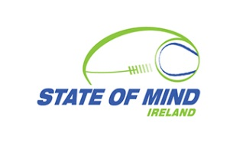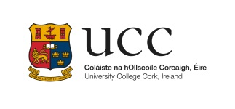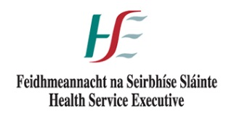
-- BOOKING FORM for 9th annual CRSI conference --

Building Bridges: Connecting For Life
Wednesday 8th June 2016 9.15 am – 4 pm

Catherine McAuley School of Midwifery & Nursing
Brookfield Health Sciences Complex, UCC, Cork

More information at http://stateofmindireland.com/events/ or email Liis Cotter, CRSI Secretary: liis.cotter@hse.ie

Name:
Employer
or group connections:
Telephone:
E-mail:

Twitter:
Date of application:

You may need to click ‘Enable Editing’ in order to type into the boxes above.
When completed, click “File” and “Save As” to save it to your Desktop.
Then attach the saved document to an e-mail to: liis.cotter@hse.ie
… and await a reply confirming your free place has been reserved …

